DESIGNATION - WOOLLOMES
PID - NONE, SET NEW MONUMENT

N 35 44 50.2

W 119 14 35.8

Set new monument in top of concrete head wall.

Additional recovery notes:
Station is located at the Woollomes Ave. and Hwy 99 interchange in Delano east of Hwy 99 and west of Union Pacific Rail Road tracts. Station is in the west-end of a concrete head wall north of the Hwy 99 north bound on ramp from Woollomes Ave. Station is located 144 ft north of the C/L of Woollomes Ave., 56.5 ft west of the C/L of High St. (Hwy 99 frontage road), 45.5 east of the C/L of the north bound on ramp, 21 ft north of the C/L of the Hwy 99 on ramp form High St. and on the extended line of the Hwy 99 Right of Way fence 16.0 ft south from the end of fence.
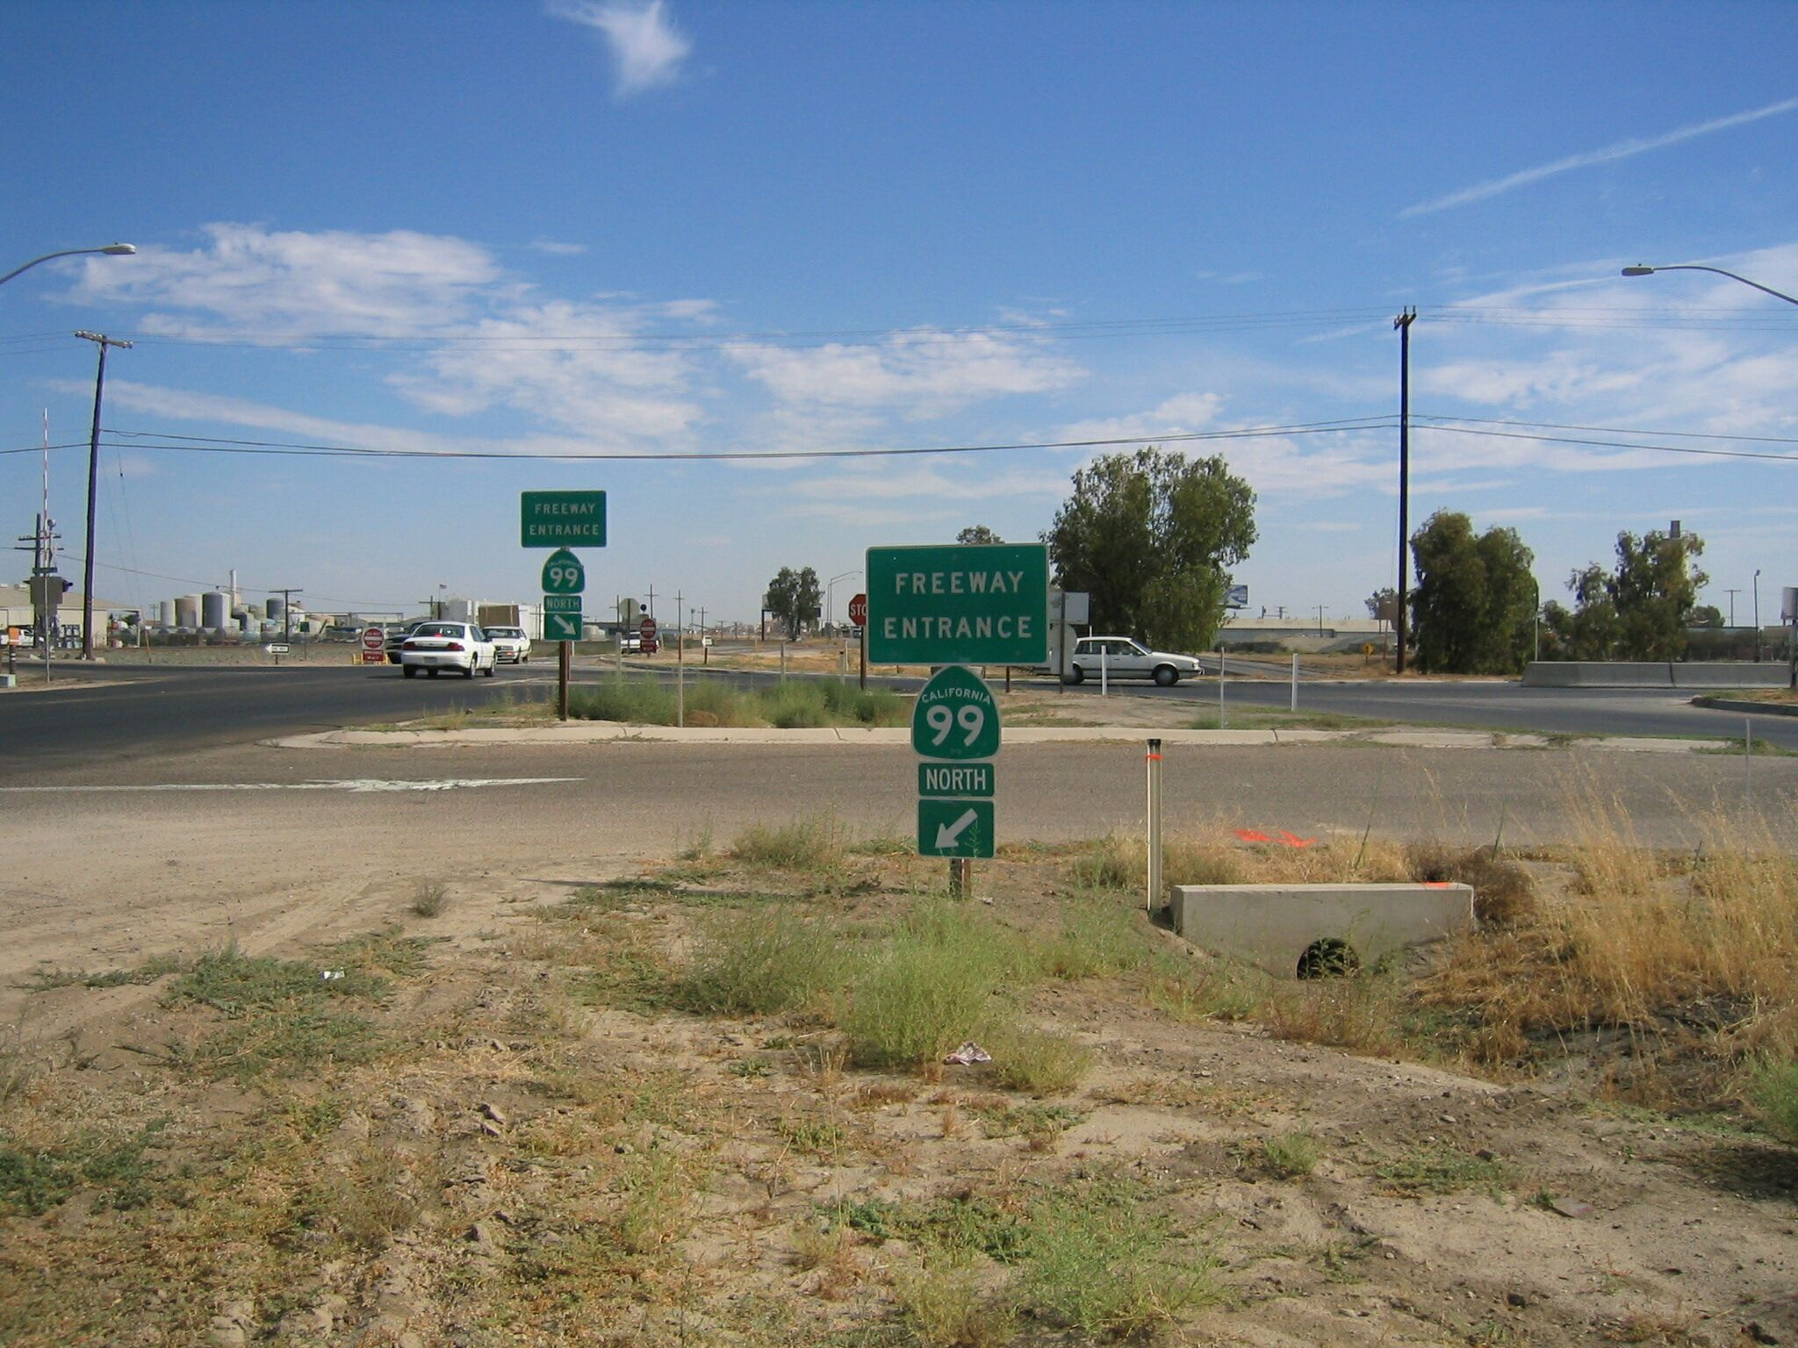
Set new
Monument
Intersection
Woollomes Ave. and High St.

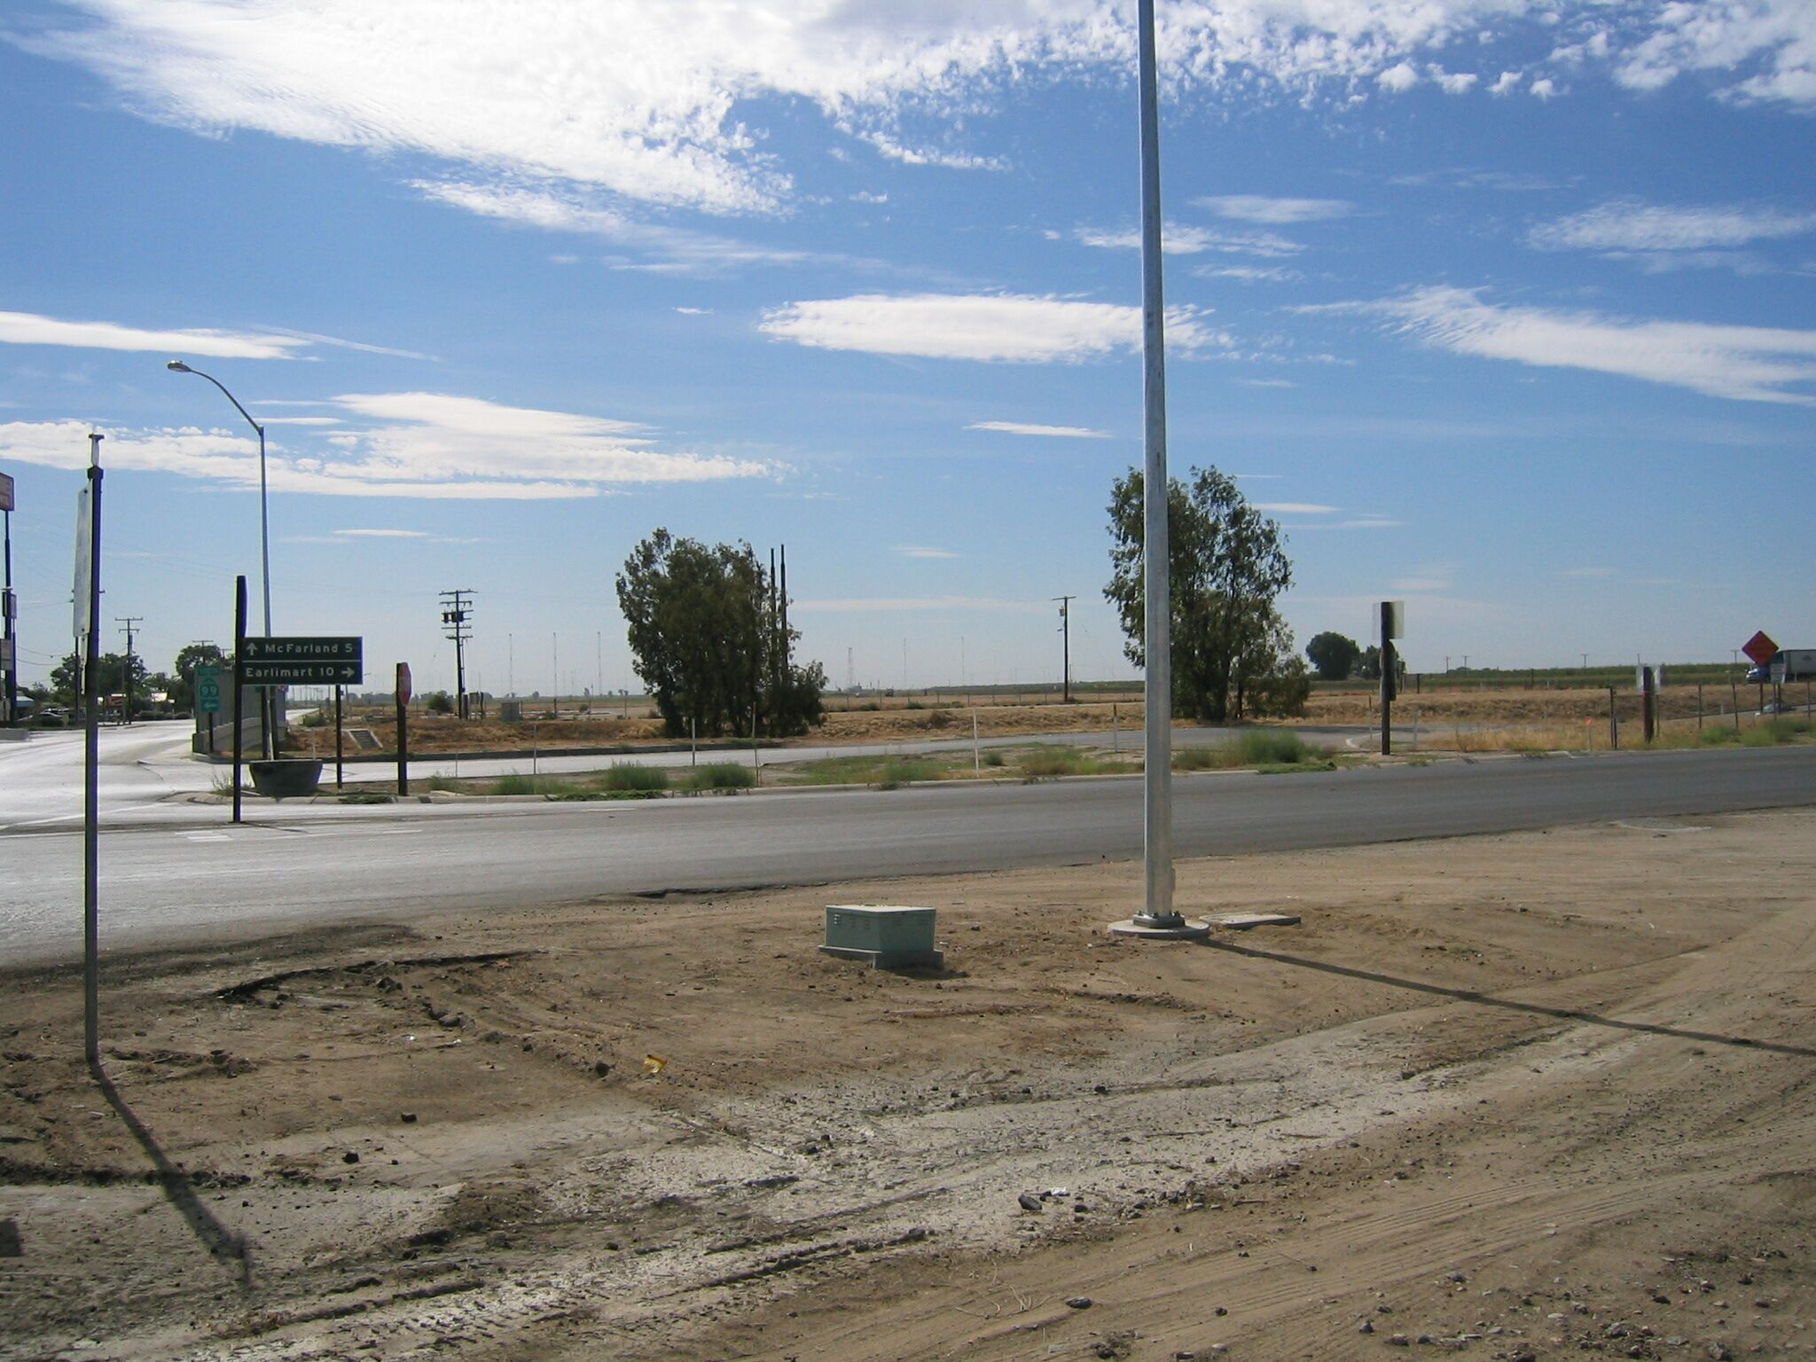
Set new
Monument

