DESIGNATION - NOTARB
PID - NONE, SET NEW MONUMENT

N 37 01 05.6

W 120 07 35.8

Set new monument in pedestrian crosswalk.

Additional recovery notes:
Station is about 5 miles northwest of Madera near Hwy 99 at Avenue 18 ½. To reach from central Madera go northwest about 5 miles to the Avenue 18 ½ interchange. Go east from the intersection of Hwy 99 and Avenue 18 ½ for 0.1 miles across the bridge over the railroad tracts to the station on the right.

Station is located on the bridge over the railroad tracts, in the pedestrian sidewalk, 24.5 feet south of the C/L of the street, 4 feet south of the south face of curb, and 2 feet west of the east end of the abutment.
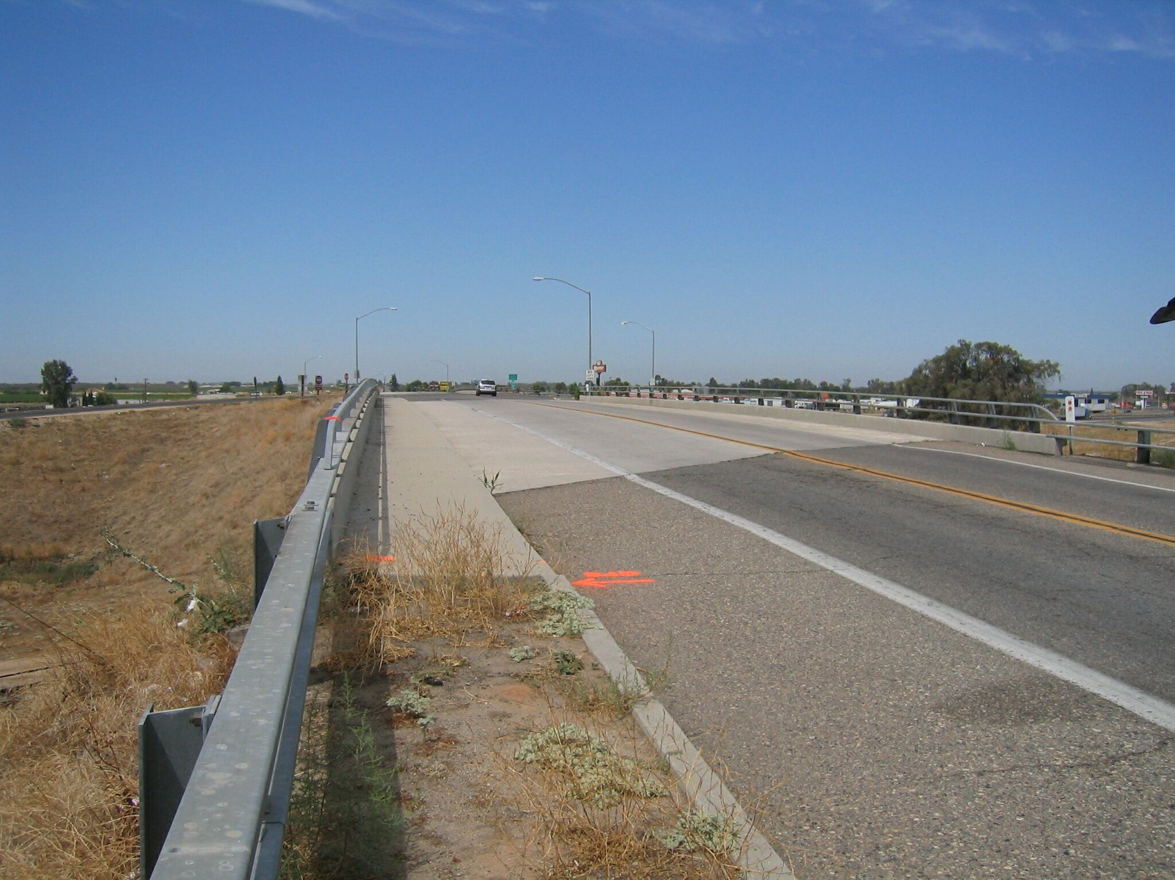
Set new
Monument

