DESIGNATION - CARTMILL
PID - NONE, SET NEW MONUMENT

N 36 14 05.2

W 119 21 15.2

Set new monument in top center of concrete structure.

Additional recovery notes:
Station is located at the north end of Tulare between the Union Pacific Rail Road line and North J Street.
To reach from the Hwy 99 and Cartmill Ave. interchange in Tulare go west on Cartmill Ave from the intersection with Hwy 99 for 0.6 miles to a cross street (North J Street). Turn left (south) onto North J Street and go 0.4 miles to a concrete headwall and the station on the right. Station is located 28.0 feet west of C/L road, 87.5 feet west and across street from a fire hydrant and 44.2 feet north of a telephone pole. Set monument in the center of the structure and which is 0.8 feet higher than the two wingwalls lying on either side.
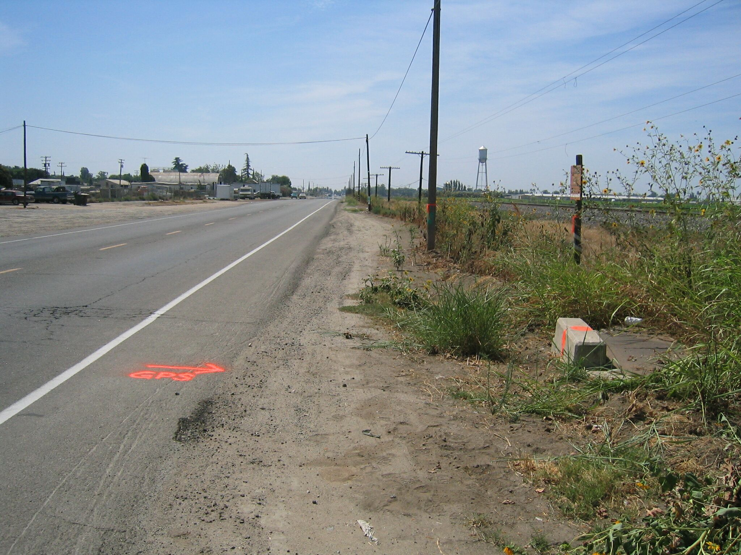
Set new
Monument

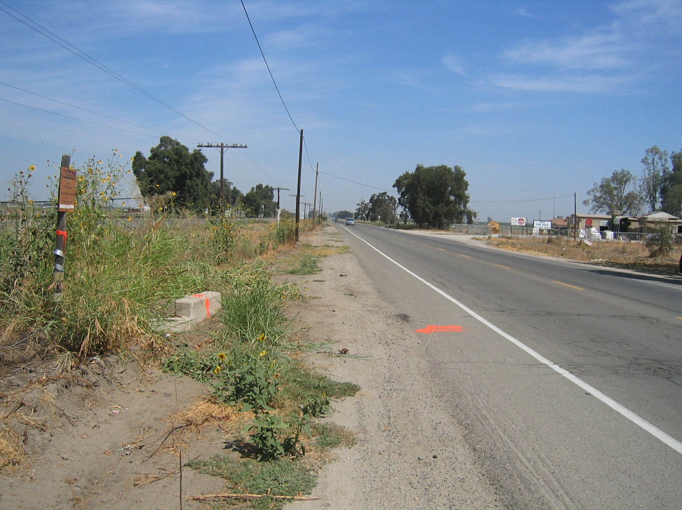
Set new
Monument

